

***TOROS UNIVERSITY***

***CSE***

**Knowledge Competition**

***Mobil Programming REPORT***

***Name:Mahsum***

***Surname:Yiğit***

***Student Id:165050003***

***CONTENT***

***1.*** ***Introductıon*** ***3***

***1.1.Knowledge competition with sqlite And What’s Android Studio? And What’s SQLite?******4***

***2.the vIsual of the applıcatıon*** ***5***

***2.1.The visuals of the application are as follows******8***

***3. androıd codes aND database******9***

***3.1.Android Codes and Database******16***

***4.Conclusıon………………………………………………..............17***

***4.1.Conclusion******17***

***5.REFERENCES******18***

***5.1.References******18***

***1.Knowledge competition with sqlite:***

***INTRODUCTION***

* *This is a beautiful android knowledge competition with SQLite database.*
* *This android app is a really forward-looking and fun knowledge competition.*
* *This android knowledge competition is tested your knowledge and understanding in different areas.*
* *The first opening of the app will write the name.*
* *And which courses will be quizzed, ease and difficulty can be adjusted.*
* *And on the other question pages there will be 3 chic answers and a number of questions on it and with a time and score on top of it.*
* *All exam data is in the local SQLite database.*
* *There are certain rules of information competition.*
* *First you can select the desired difficulty and category in the input screen.*
* *Then you can start the test with the button on the input screen.*
* *There are 3 questions for each category and degree of difficulty, and the time allocated to each question at the beginning of the exam is 15 seconds and I linked the questions from the tables we created in our database.(SQLite)*
* *I created a total of 27 questions.*

***What’s SQLite?***



*SQLite is a relational SQL database engine that is fully open source, coded using C and C ++ programming languages, does not require configuration for server software, and provides advice for its most distributed use around the world.SQLite database can be easily used in all programming languages.Some examples are; ASP, BASIC, C #, C, C ++, Delphi, Java, PHP, Python, Visual Basic. And I retrieved the data using the SQLite application for the database.*

***What’s Android Studio?***

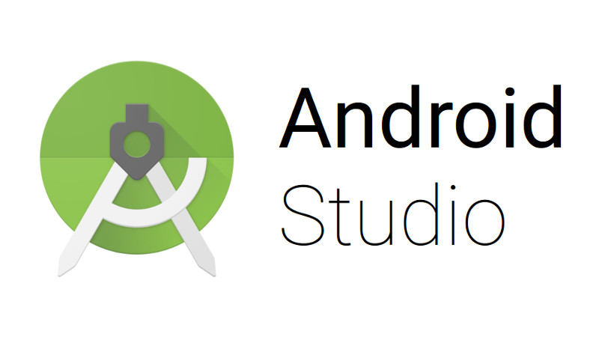

*Android Studio is an extremely comprehensive and free of charge software program designed for Android application developers.*

*The program comes with more than one Android developer tool.*

*With Android Studio, you can easily solve complex problems, not only to improve the application, but also to solve problems in existing applications,you can realize.Android Studio, a large and comprehensive program, makes it easy for people who want to develop Android and is a successful program produced by Google to help them with the problems they face.*

*If you want to develop applications on Android, Android Studio is your biggest helper in this field.* *And I did this project using the Android Studio application.*

***2.The visuals of the application are as follows;***

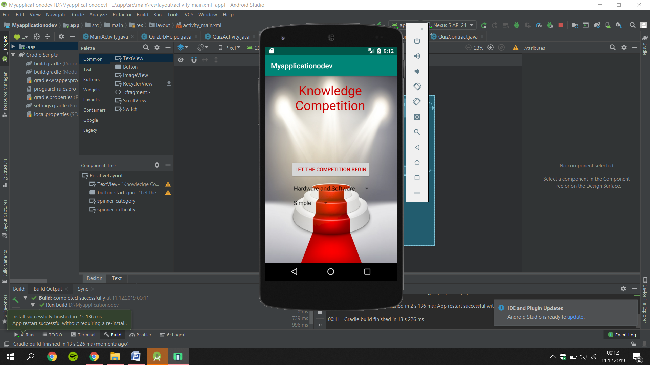

***(Image 2.1)***

***(The start screen is as follows.)***

***\*The image related to a category and difficulty level is as follows;***

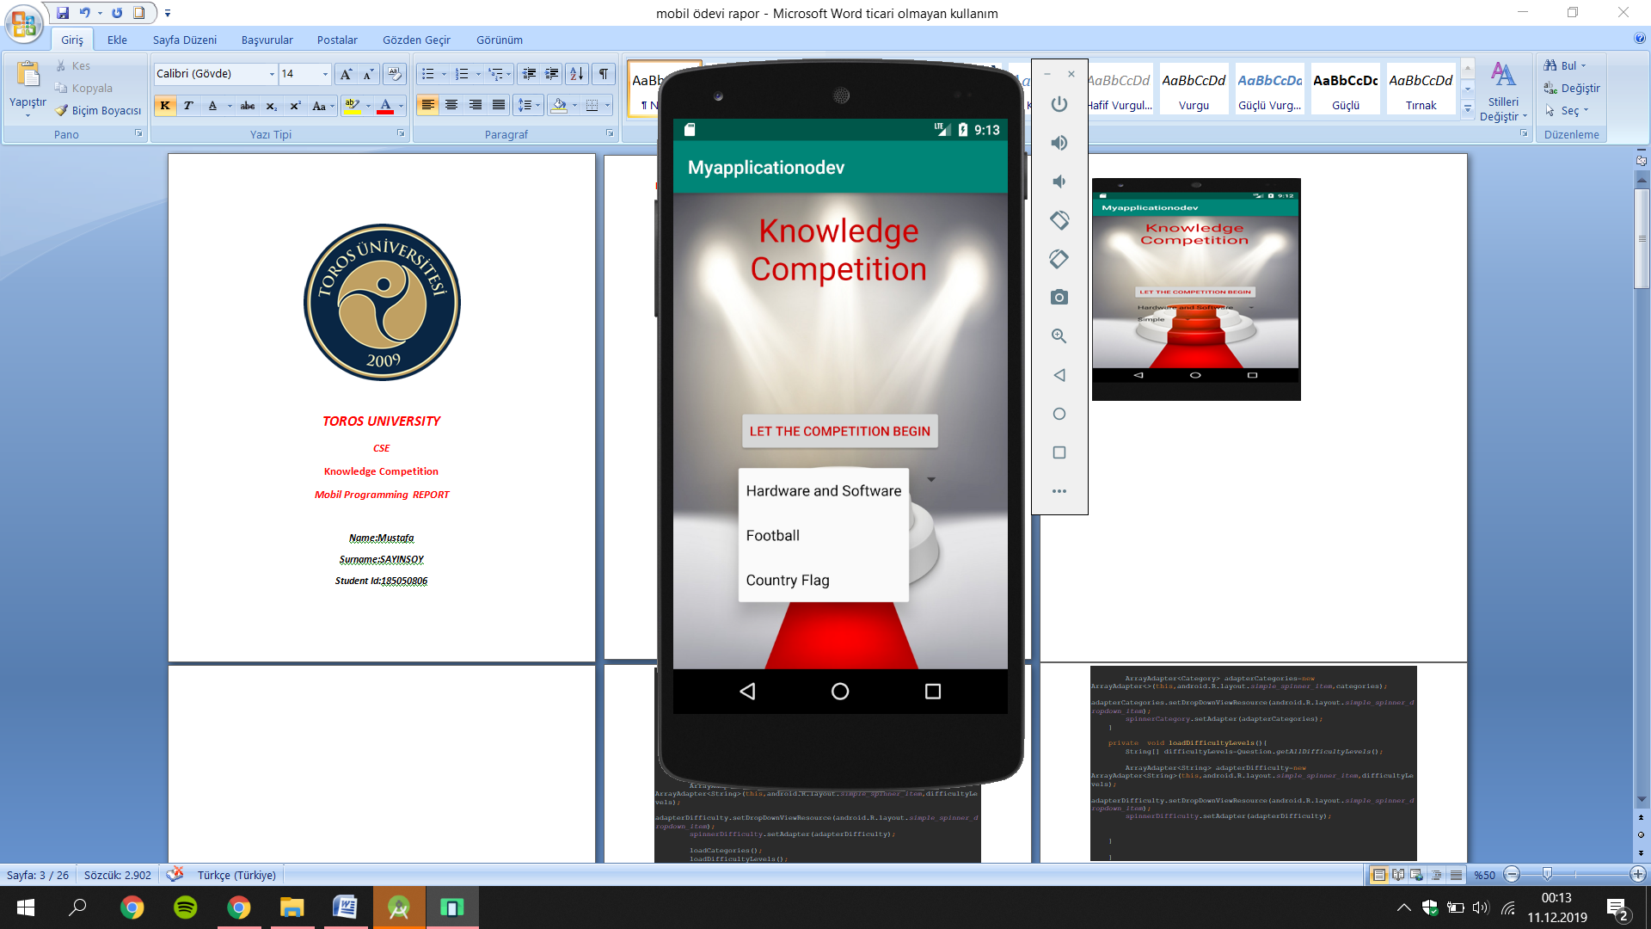

***(Image 2.2)***

***Categories are hardware and software, football and national flags.***

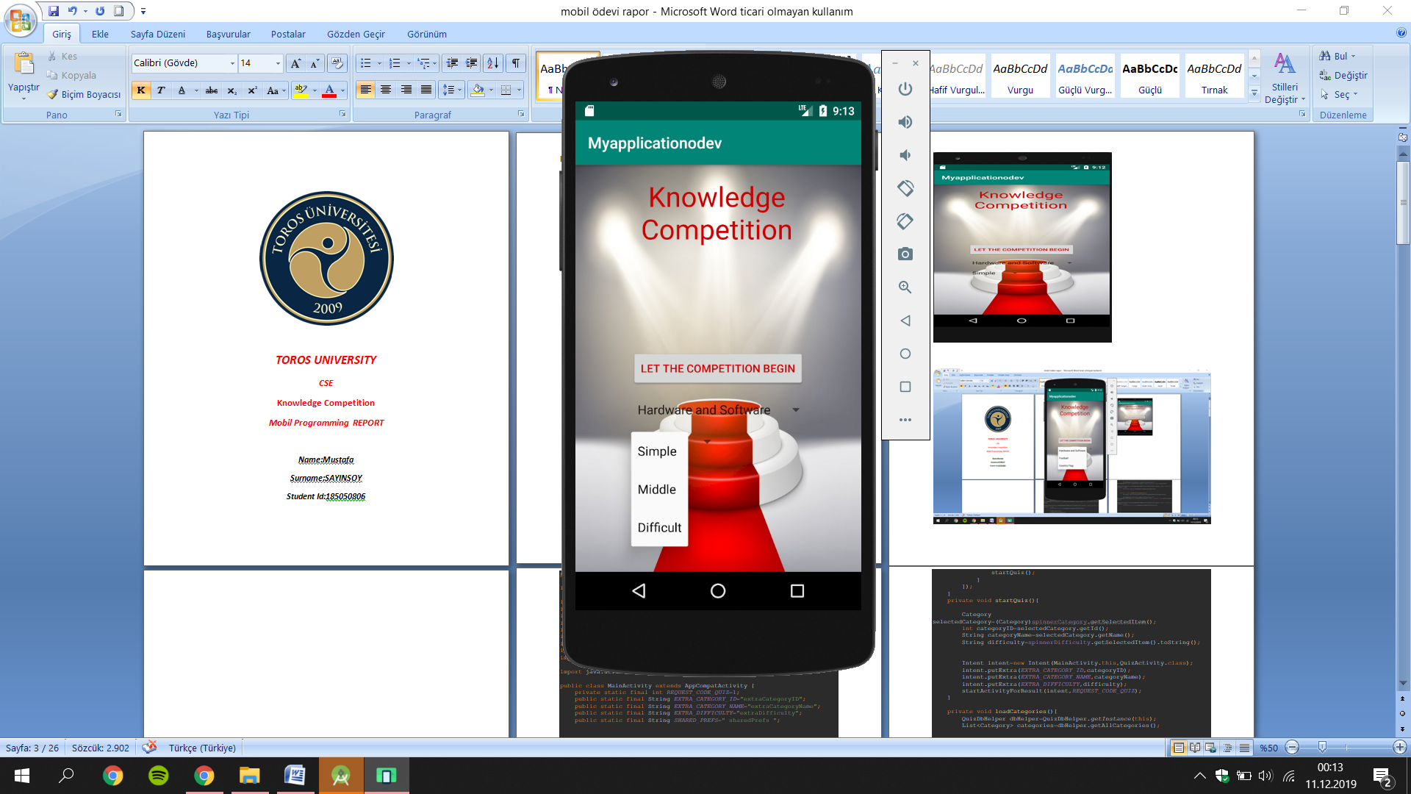

***(Image 2.3)***

***Degrees of difficulty are Simple, Middle and Difficult.***

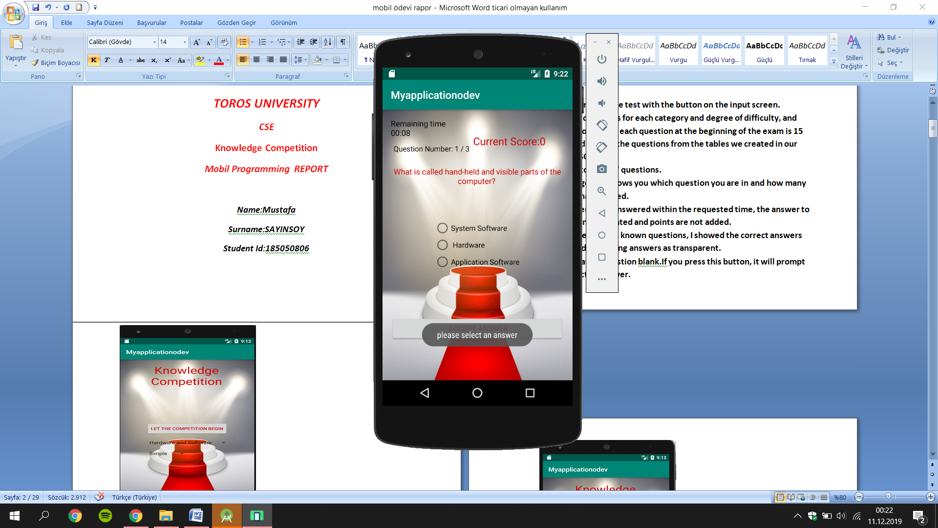

***(Image2.4)***

***We can't leave a question blank.If you press this button, it will prompt you to select an answer.***

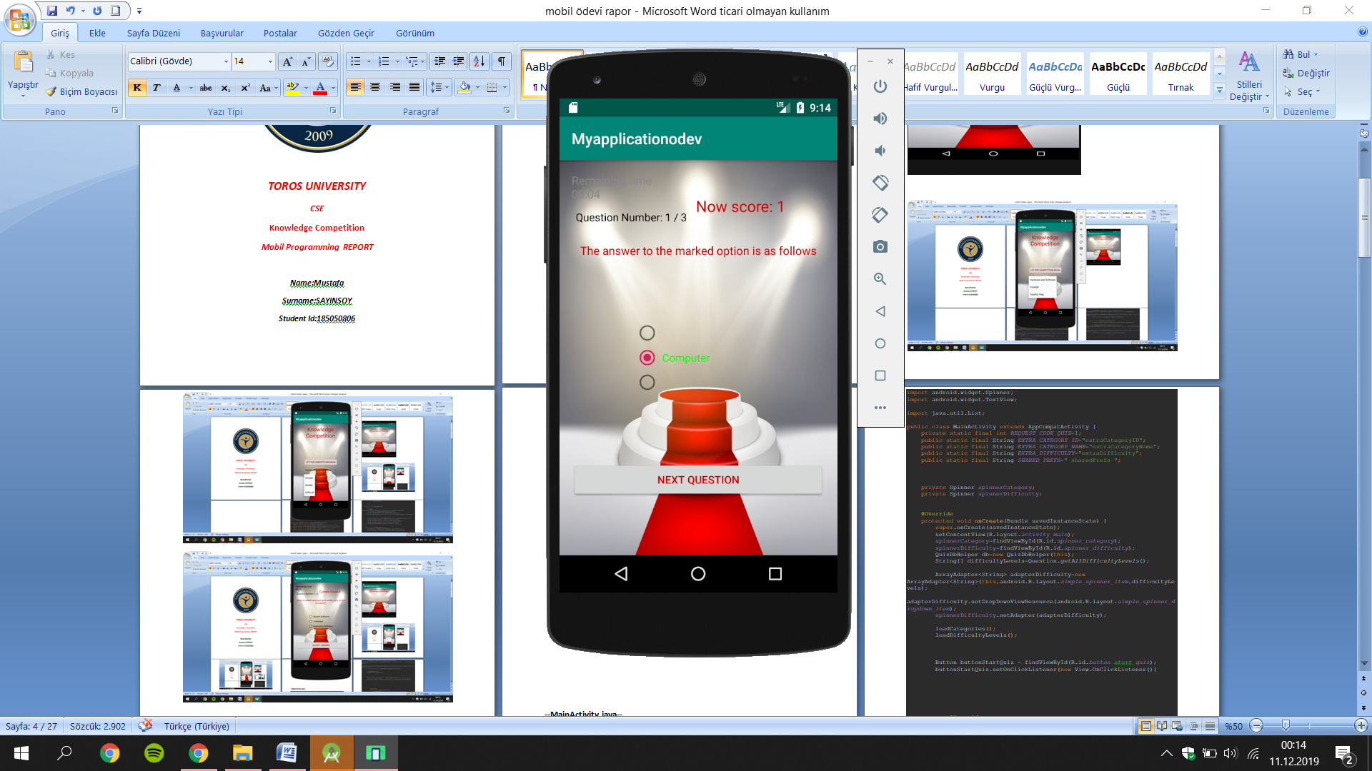

***(Image 2.5)***

***Remaining time, turns gray before the last 5 seconds.***

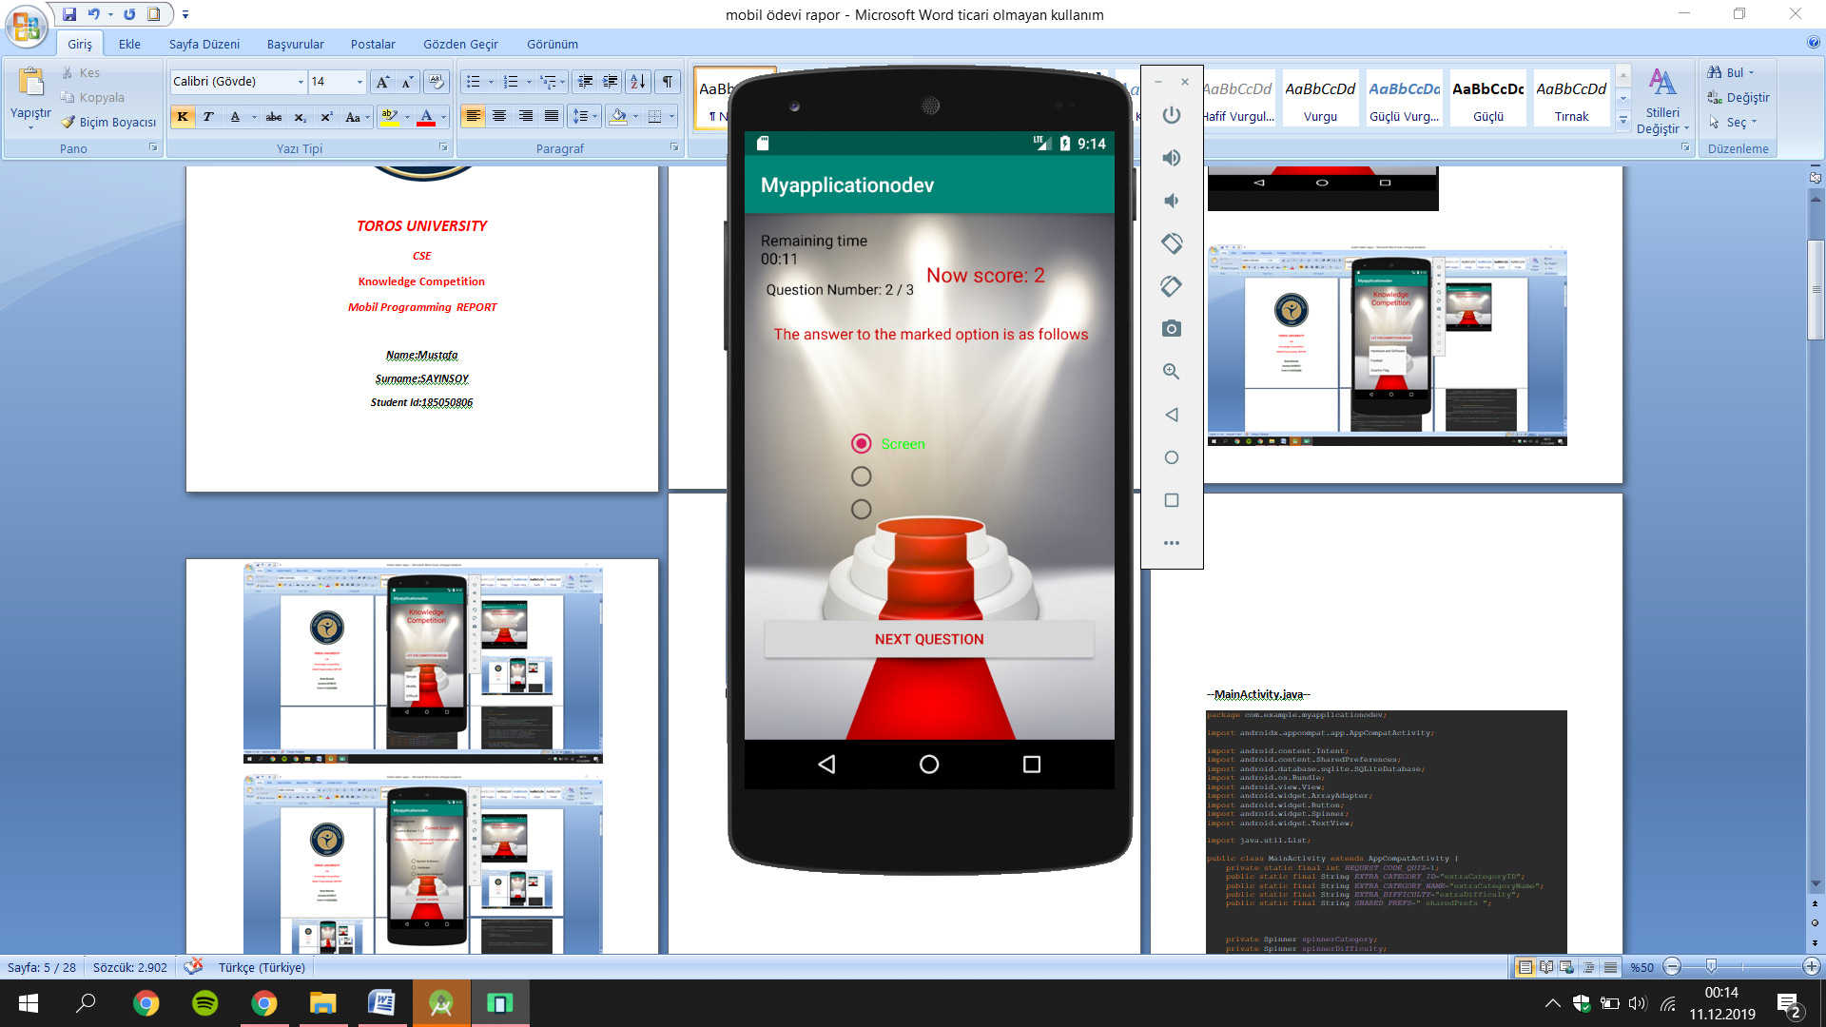

***(Image 2.6)***

***The test page also shows you which question you are in and how many points you have scored.***

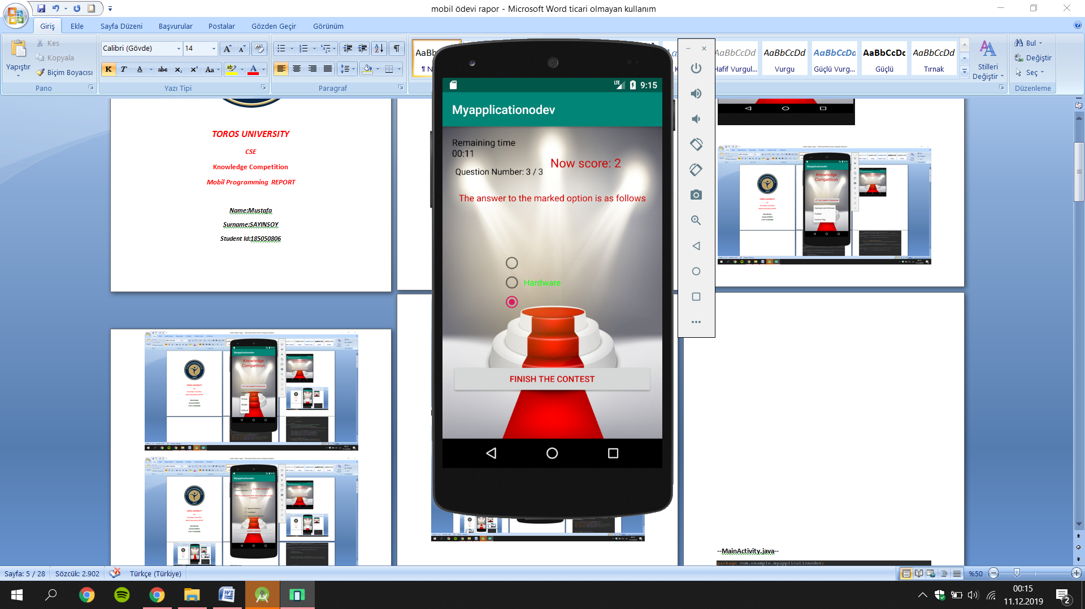

***(Image 2.7)***

***In the answers to the known questions, I showed the correct answers as green and the wrong answers as transparent.***

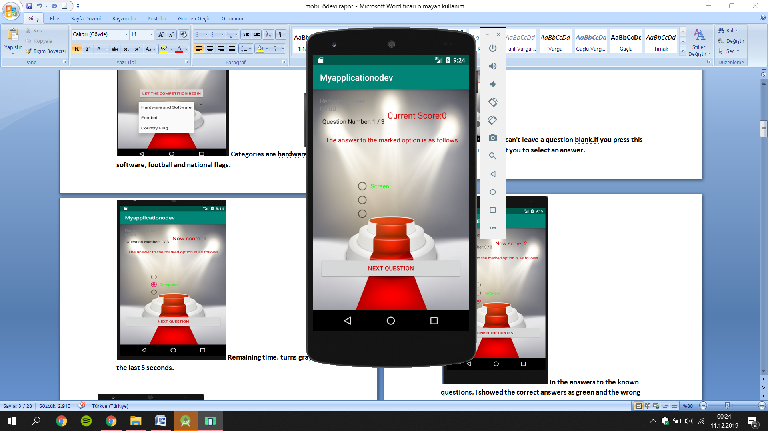

***(Image 2.8)***

***If the answer is not answered within the requested time, the answer to the question is indicated and points are not added.***

***3.Android Codes***

***MainActivity.java***

*private void startQuiz(){  
  
 Category selectedCategory=(Category)spinnerCategory.getSelectedItem();  
 int categoryID=selectedCategory.getId();  
 String categoryName=selectedCategory.getName();  
 String difficulty=spinnerDifficulty.getSelectedItem().toString();  
  
  
 Intent intent=new Intent(MainActivity.this,QuizActivity.class);  
 intent.putExtra(EXTRA_CATEGORY_ID,categoryID);  
 intent.putExtra(EXTRA_CATEGORY_NAME,categoryName);  
 intent.putExtra(EXTRA_DIFFICULTY,difficulty);  
 startActivityForResult(intent,REQUEST_CODE_QUIZ);  
 }  
  
 private void loadCategories(){  
 QuizDbHelper dbHelper=QuizDbHelper.getInstance(this);  
 List<Category> categories=dbHelper.getAllCategories();  
  
  
 ArrayAdapter<Category> adapterCategories=new ArrayAdapter<>(this,android.R.layout.simple_spinner_item,categories);  
 adapterCategories.setDropDownViewResource(android.R.layout.simple_spinner_dropdown_item);  
 spinnerCategory.setAdapter(adapterCategories);  
 }  
  
 private void loadDifficultyLevels(){  
 String[] difficultyLevels=Question.getAllDifficultyLevels();  
  
 ArrayAdapter<String> adapterDifficulty=new ArrayAdapter<String>(this,android.R.layout.simple_spinner_item,difficultyLevels);  
 adapterDifficulty.setDropDownViewResource(android.R.layout.simple_spinner_dropdown_item);  
 spinnerDifficulty.setAdapter(adapterDifficulty);  
  
  
 }  
  
 }*

***//Here the code sets the start button category and difficulty level.***

***Category.java***

*package com.example.myapplicationodev;  
public class Category {  
  
 public static final int HARDWAREANDSOFTWARE=1;  
 public static final int FOOTBALL=2;  
 public static final int COUNTRYFLAG=3;  
  
 private int id;  
 private String name;  
  
 public Category(){  
 }  
  
 public Category(String name) {  
 this.name = name;  
 }  
  
 public int getId() {  
 return id;  
 }  
  
 public void setId(int id) {  
 this.id = id;  
 }  
  
 public String getName() {  
 return name;  
 }  
  
 public void setName(String name) { this.name = name; }  
 @Override  
 public String toString(){  
 return getName();  
 }  
}*

***//Category-related settings and the names of the categories.***

***QuizDbHelper.java***

*public class QuizDbHelper extends SQLiteOpenHelper {  
  
 private static final String DATABASE_NAME = "Quizdtaaaaaa";*

***// Where database name is written***

*final String SQL_CREATE_CATEGORIES_TABLE = " CREATE TABLE " +  
 CategoriesTable.TABLE_NAME + " ( " +  
 CategoriesTable._ID + " INTEGER PRIMARY KEY AUTOINCREMENT," +  
 CategoriesTable.COLUMN_NAME + " TEXT " +  
 ")";  
  
 final String SQL_CREATE_QUESTIONS_TABLE = " CREATE TABLE " +  
 QuestionsTable.TABLE_NAME + " ( " +  
 QuestionsTable._ID + " INTEGER PRIMARY KEY AUTOINCREMENT, " +  
 QuestionsTable.COLUMN_QUESTION + " TEXT ," +  
 QuestionsTable.COLUMN_OPTION1 + " TEXT, " +  
 QuestionsTable.COLUMN_OPTION2 + " TEXT, " +  
 QuestionsTable.COLUMN_OPTION3 + " TEXT, " +  
 QuestionsTable.COLUMN_ANSWER_NR + " INTEGER," +  
 QuestionsTable.COLUMN_DIFFICULTY + " TEXT, " +  
 QuestionsTable.COLUMN_CATEGORY_ID + " INTEGER, " +  
 "FOREIGN KEY (" + QuestionsTable.COLUMN_CATEGORY_ID + ") REFERENCES " +  
 CategoriesTable.TABLE_NAME + "(" + CategoriesTable._ID + ")" + " ON DELETE CASCADE " +  
 ")";  
 db.execSQL(SQL_CREATE_CATEGORIES_TABLE);  
 db.execSQL(SQL_CREATE_QUESTIONS_TABLE);  
 fillCategoriesTable();  
 fillQuestionsTable();  
 }****// Category and Questions table is written***

*private void fillQuestionsTable() {  
 Question q1 = new Question("Which of the following is true?",  
 " 1 KB = 1024 Byte ", " 1 Kilobyte = 8 Bit ", " 1024 MB = 1 KB ", 1, Question.DIFFICULTY_DIFFICULTY, 1);  
 insertQuestion(q1);  
 Question q2 = new Question("Which country won the first World Cup?",  
 " Brazil ", " Uruguay ", " Germany ", 2, Question.DIFFICULTY_DIFFICULTY, 2);  
 insertQuestion(q2);  
 Question q3 = new Question("Which country has the moon and star in the flag? ",  
 " Spain ", " Germany ", " Turkey ", 3, Question.DIFFICULTY_DIFFICULTY, 3);  
 insertQuestion(q3);  
 Question q4 = new Question("Which country is only the flag red black ?",  
 " Angola ", " Spain ", " Germany ", 1, Question.DIFFICULTY_SIMPLE, 3);  
 insertQuestion(q4);  
 Question q5 = new Question("Who is the player who scored the most goals in the Champions League with a club uniform? ",  
 " Lionel Messi", " Cristiano Ronaldo ", " Karim Benzema ", 1, Question.DIFFICULTY_SIMPLE,2);  
 insertQuestion(q5);  
 Question q6 = new Question("UEFA Champions League final between which teams and when was played in Istanbul? ",  
 " Liverpool-Milan(2004) ", " Liverpool-Milan(2005)", " Liverpool-Milan(2003) ", 2, Question.DIFFICULTY_MIDDLE,2);  
 insertQuestion(q6);  
 Question q7 = new Question("Which is not one of the countries with the moon star? ",  
 "Algeria ", " Cameroon ","Tunisian", 2, Question.DIFFICULTY_MIDDLE,3);  
 insertQuestion(q7);  
 Question q8 = new Question("Which of the following is not a programming language? ",  
 " Delphi ", " Windows XP ", " Python ", 2, Question.DIFFICULTY_MIDDLE,1);  
 insertQuestion(q8);  
 Question q9 = new Question("What is the name given to the entire software and hardware? ",  
 " Information ", " Computer ", " Tecnology ", 2, Question.DIFFICULTY_SIMPLE,1);  
 insertQuestion(q9);*

***// Code for the first 9 questions (27 questions in total)***

***QuizActivity.java*** *public class QuizActivity extends AppCompatActivity {  
 public static final String EXTRA_SCORE = " extraScore ";  
 private static final long COUNTDOWN_IN_MILLIS = 15000;*

***// The duration of the knowledge competition is determined here.*** *@Override  
 public void onClick(View v) {  
 if (!answered) {  
 if (rb1.isChecked() || rb2.isChecked() || rb3.isChecked()) {  
 checkAnswer();  
 } else {  
 Toast.makeText(QuizActivity.this, " please select an answer ", Toast.LENGTH_SHORT).show();  
 }  
 } else {  
 showNextQuestion();  
 }  
 }  
 });  
 }*

***// If an option is not selected here, it will say please select a reply as a message*** *private void showSolution() {  
 rb1.setTextColor(Color.TRANSPARENT);  
 rb2.setTextColor(Color.TRANSPARENT);  
 rb3.setTextColor(Color.TRANSPARENT);  
 switch (currentQuestion.getAnswerNr()) {  
 case 1:  
 rb1.setTextColor(Color.GREEN);  
 textViewQuestion.setText(" The answer to the marked option is as follows");  
 break;  
 case 2:  
 rb2.setTextColor(Color.GREEN);  
 textViewQuestion.setText("The answer to the marked option is as follows");  
 break;  
 case 3:  
 rb3.setTextColor(Color.GREEN);  
 textViewQuestion.setText(" The answer to the marked option is as follows ");  
 break;  
 }*

***// The correct answer in the options is gren and makes the wrong answer transparent.***

***Question.java*** *public class Question implements Parcelable {  
  
 public static final String DIFFICULTY_SIMPLE= "Simple";  
 public static final String DIFFICULTY_MIDDLE="Middle";  
 public static final String DIFFICULTY_DIFFICULTY="Difficult";*

***// The code that determines the difficulty levels of the questions.***

***QuizContract.java***

*package com.example.myapplicationodev;  
import android.provider.BaseColumns;  
public final class QuizContract {  
 private QuizContract(){  
 }  
 public static class CategoriesTable implements BaseColumns{  
 public static final String TABLE_NAME= "quiz_categories";  
 public static final String COLUMN_NAME="name";  
 }  
 public static class QuestionsTable implements BaseColumns{  
 public static final String TABLE_NAME="quiz_question";  
 public static final String COLUMN_QUESTION="question";  
 public static final String COLUMN_OPTION1="option1";  
 public static final String COLUMN_OPTION2="option2";  
 public static final String COLUMN_OPTION3="option3";  
 public static final String COLUMN_ANSWER_NR="answer_nr";  
 public static final String COLUMN_DIFFICULTY="difficulty";  
 public static final String COLUMN_CATEGORY_ID="category_id";  
 }  
}*

***// This code is the section where the category and the table of questions are set.***

***Database(SQLite)***

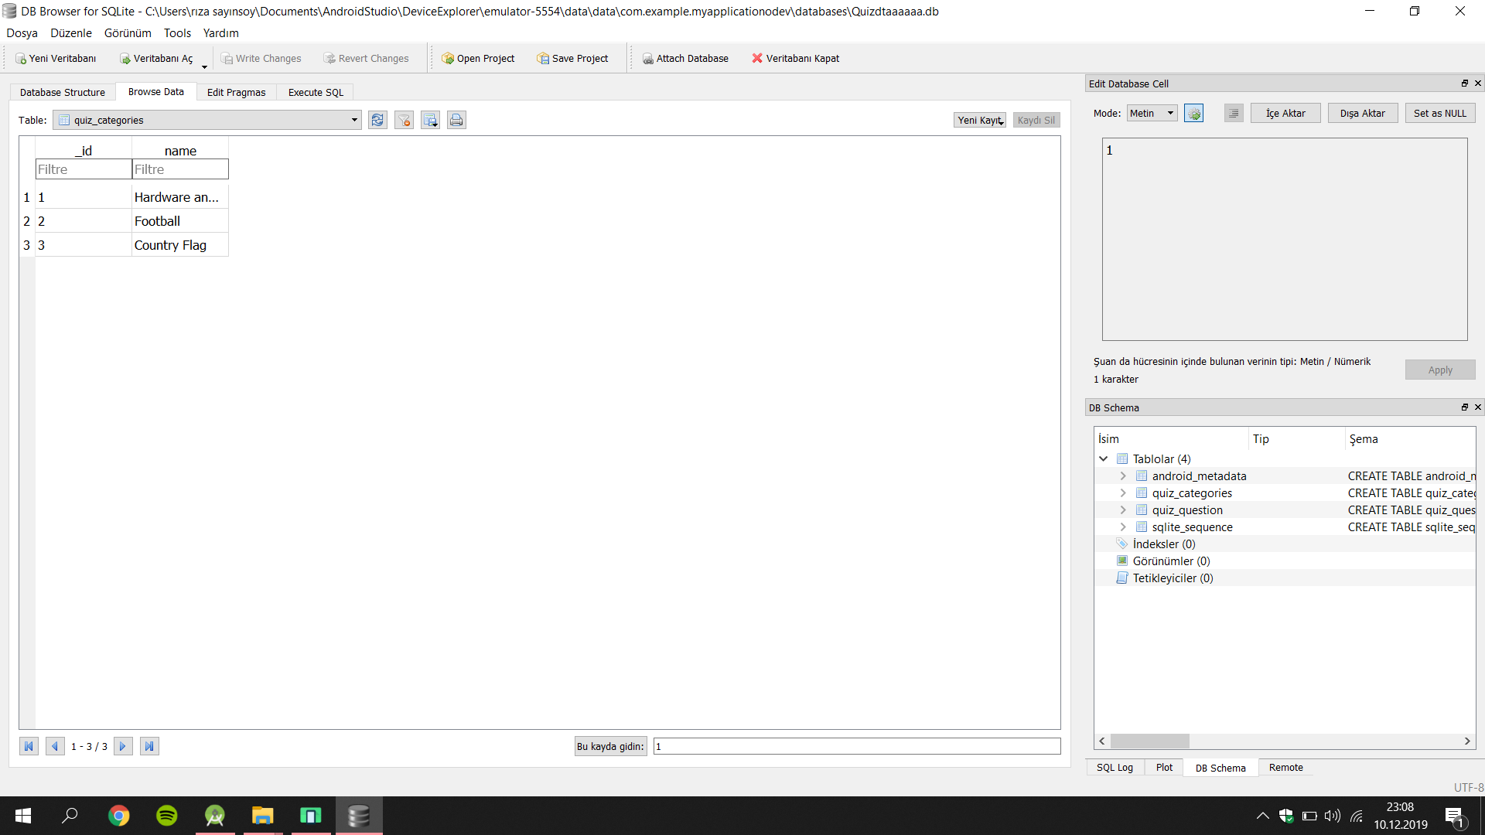

***(Image 3.1)***

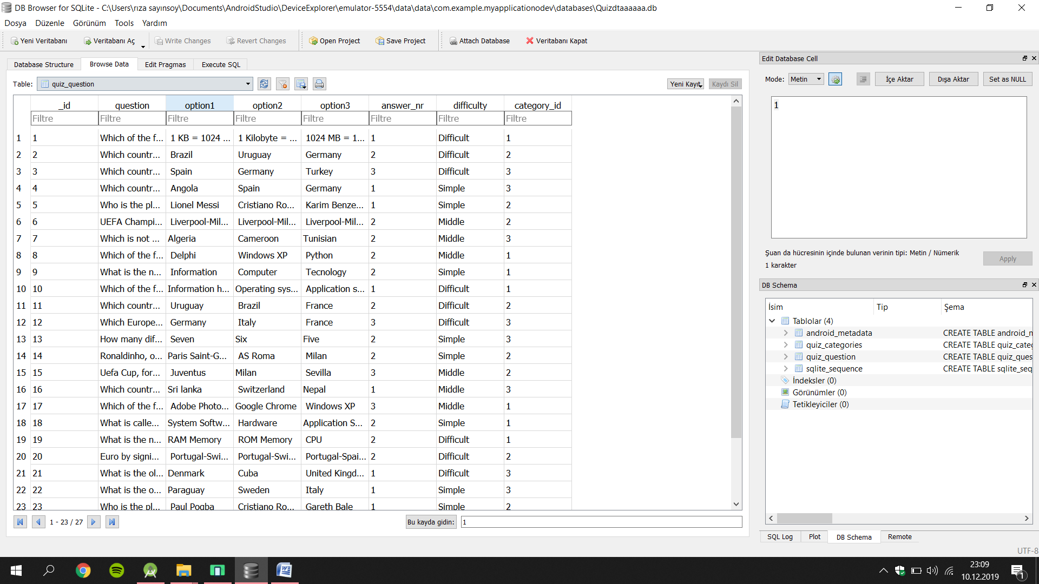

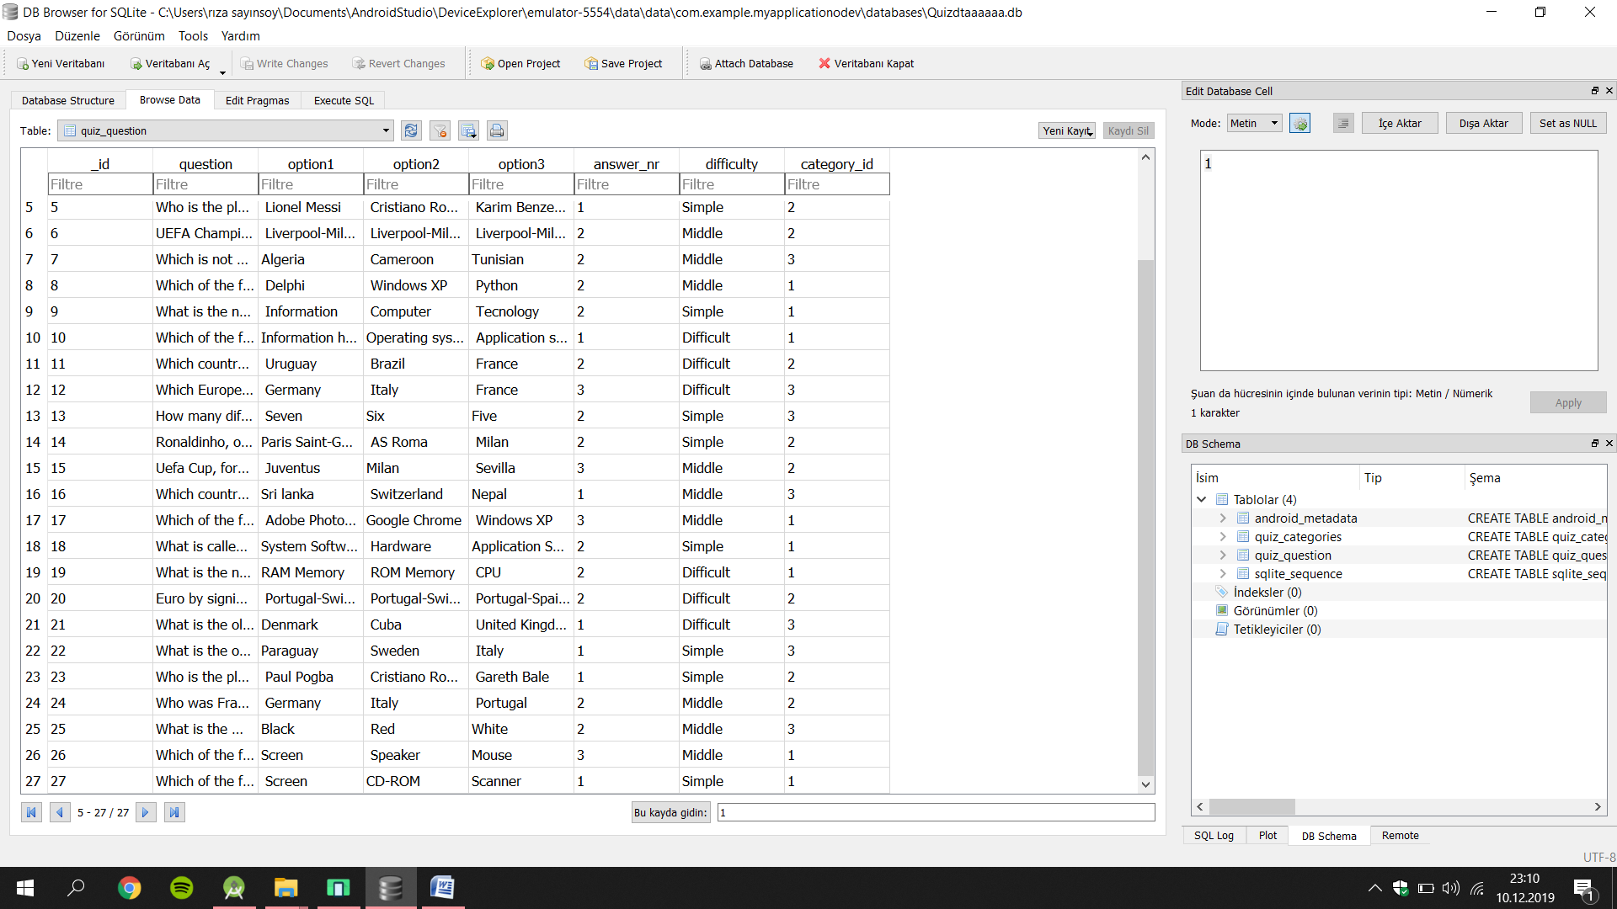

***(Image 3.2)***

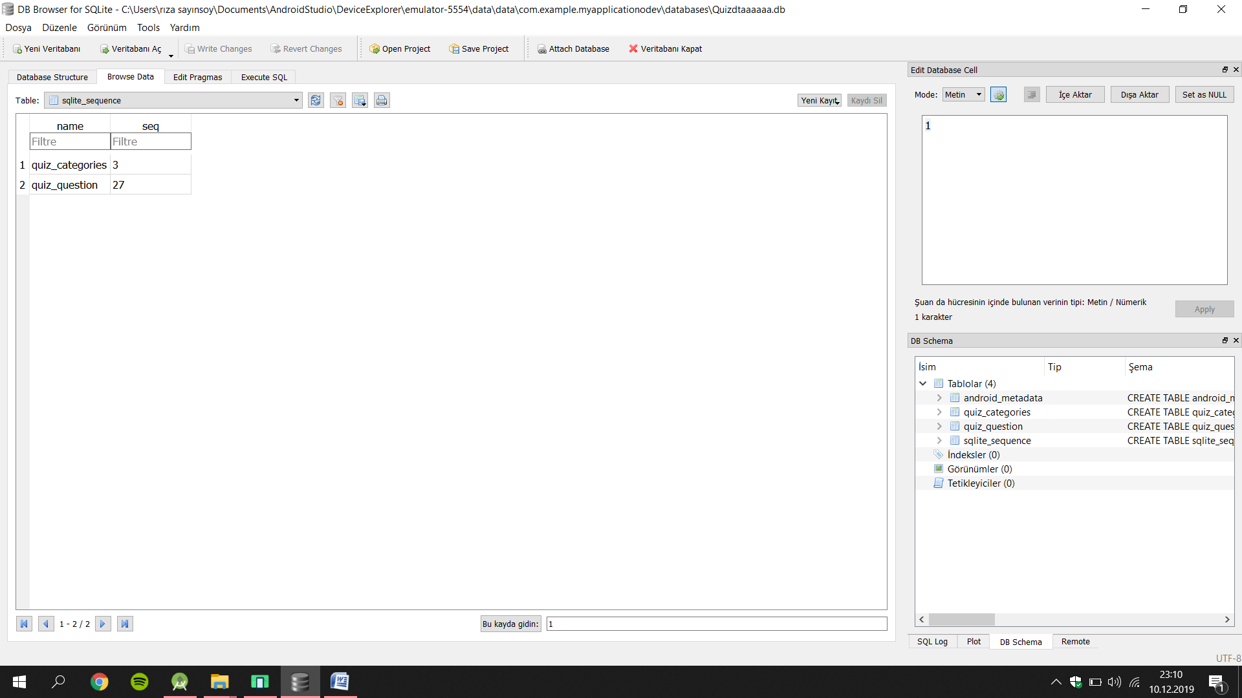

***(Image 3.3)***

***4.CONCLUSION***

*First, the purpose of choosing such an application is to learn and have fun.*

*So I think this application is very useful. To prepare this application, I took advantage of a coding application called android studio.*

*And the most important purpose in the application is to use the database. And the database I use is SQLite.*

*My goal is to send questions from the database to the application and through SQLite I have sent the questions from the database.*

***5.REFERENCES***